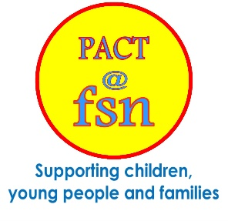
PACT (Parents and Children Together)
Providing Early Years support groups for families with pre-school children including access to FSN’s food pantry, and promotion of current health programmes
Parent/Carer Names: |  |  |  | Parent/Carer Tel No:
Parent/Carer Address: |  |  |  | Parent/Carer Email:
Child Name: |  |  |  | Date of Birth:
Child Name: |  |  |  | Date of Birth:
Child Name: |  |  |  | Date of Birth:
Other agencies working with family: |  |  |  | Agency contact details:
Referrers Name: |  |  |  | Referrers Tel No:
Referrers Job Title: |  |  |  | Referrers Email:
Reason for Referral
Wellbeing |  |  | Peer Support |  |  | Socialisation
Health |  |  | Loneliness |  |  | Family Issues
Safeguarding
Child Protection Plan |  |  | Child in Need Plan |  |  | Looked After Child
Health
Parent |  | Physical Disability |  |  |  | Neuro Diverse
Child(ren) |  | Physical Disability |  |  |  | Neuro Diverse
For Office Use Only
Date Referral Received |  | PR Number

