**DIVERSITY, EQUITY AND INCLUSION POLICY**

**1.0 Objectives**

**1.1** FSN is fully committed to the principles of equality of opportunity and takes its responsibility very seriously in ensuring that no-one involved with FSN whether a member of staff, a volunteer, service user or visitor receives less favourable treatment on the grounds of age, disability, gender reassignment, marriage and civil partnership, pregnancy and maternity, race, religion or belief, sex and sexual orientation.

**1.2** FSN recognises that we live in a diverse society and will take all necessary steps to ensure that anyone participating in our projects, services and activities in whatever capacity will be treated fairly and offered the same opportunities regardless of background.

**1.3** FSN is committed to seeking to work and partner with organisations who share the same principles and practice as set out in this policy.

**2.0** **Definitions**

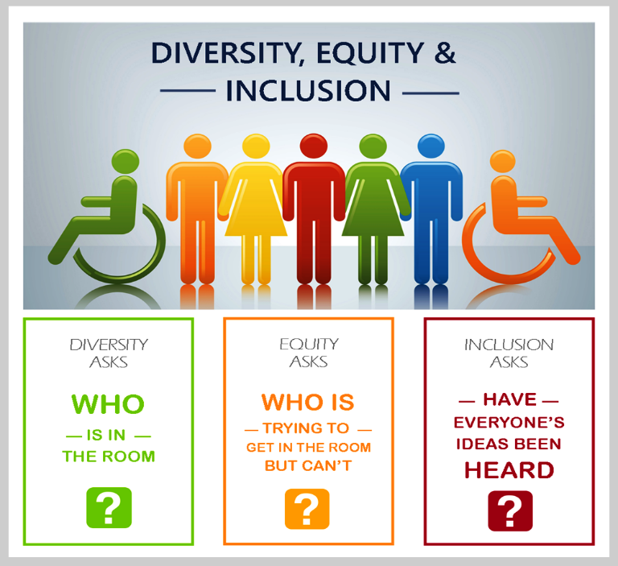

**2.1 Diversity –** recognising, valuing and managing difference and acknowledging that individuals have different needs which can be met in different ways.

**2.2** **Equity –** the situation in which everyone is treated fairly according to their needs and no group of people is given special treatment. 1

**2.3 Inclusion –** ensuring belonging, respect and being heard.

**3. Legal Requirements**

**3.1** FSN fully recognises its legal obligations, and will abide by the requirements of the Equality Act 2010 and any later amendments to the Act or subsequent equality related legislation that may be relevant.

**4. Statement of Intent – FSN:**

**4.1** wishes to act as an example for diversity, equity and inclusion and will work to influence and promote good practice.

**4.2** will ensure that the responsibility and accountability is placed at the most senior levels of the organisation with the Chief Executive having overall responsibility and accountability for the effective implementation of this policy, and both the Senior Management Team and the Board monitoring its effectiveness.

**4.3** will include diversity into all aspects of its work with reasonable steps being taken to ensure that all staff, volunteers, contractors etc. are committed to this policy.

**4.4** will ensure that no job applicant or employee receives less favourable treatment on the grounds of any protected characteristic (see 1.1)

**4.5** will work to ensure that there will be open access to all those who wish to participate in FSN activity and they are treated fairly and with respect.

**4.6** is committed to ensure that anyone engaged in FSN activities, services and projects are free from bullying and harassment and has policies in place to deal with such matters.

**5.0 Discrimination, Harassment, Bullying and Victimisation**

**5.1 Direct Discrimination –** occurs when someone is treated less favourably than another person because of a protected characteristic (see 1.1).

**5.2** **Indirect Discrimination –** occurs when there is a condition, rule or practice which applies to everyone but particularly disadvantages people who share a protected characteristic (see 1.1).

**5.3** **Discrimination by Association –** is direct discrimination against someone because they associate with another person who possesses a protected characteristic.

**5.4 Discrimination by Perception –** is direct discrimination against an individual because others think they possess a particular protected characteristic, even if they don’t actually possess it or if the perception was mistaken.

**5.5 Harassment –** engaging in unwanted conduct relating to a relevant protected characteristic (see 1.1) or unwanted conduct of a sexual nature where the conduct has the purpose or effect of violating the recipient’s dignity or creating an intimidating, hostile, degrading, humiliating or offensive environment for the recipient, or any other individual affected by such conduct. It also includes the right for individuals to raise an issue that they find offensive even if it is not directed at them.

**5.6 Bullying –** the misuse of power or position to criticise persistently or to humiliate and undermine an individual’s confidence.

**5.7 Victimisation –** when someone is treated badly because they have made or supported a complaint/grievance about discrimination or harassment under the Equality Act 2010, or are suspected of either making or supporting such a complaint/grievance. An individual is not protected from victimisation if they acted maliciously, or made or supported an untrue complaint/grievance.

**5.8 Third Party Harassment –** relates to actions carried out by non FSN individuals such as service users, customers, contractors etc. FSN will investigate any report or complaint and take all reasonable steps to prevent it from recurring.

**5.9** FSN regards discrimination, harassment, bullying or victimisation as serious misconduct. All complaints will be taken seriously and appropriate measures including disciplinary action may be brought against any member who unlawfully discriminates against, harasses, bullies or victimises any other person.

**6. Implementation, Responsibilities and Communication**

**FSN will:**

**6.1** make a copy of this policy available to view on its website which makes it clear that all individuals have responsibilities to respect, act in accordance with, support and promote the spirit and intentions of this policy.

**6.2** ensure that this policy is an integral part of the recruitment, induction and on-going training for all staff.

**6.3** recognise that it has a duty to make reasonable adjustments for disabled people. We will consider all requests for adjustment and where possible accommodate reasonable requests and work with disabled staff, volunteers and service users to implement any adjustments that will enable them to participate fully in FSN work and activities.

**6.4** ensure that any consultants, contractors, partners, agents, advisors etc. are appointed fairly and equally and are directed to this policy and will be required to demonstrate their commitment to the principles and practices of this policy.

**6.5** continue to support an Action Plan within which specified roles, responsibilities and resources are allocated. Progress against the plan will be reported to the Board of Trustees at least twice per year.

**6.6** ensure all managers are required to set an appropriate standard of behaviour, that they lead by example and ensure that those they manage adhere to this policy and promote the organisation’s aims and objectives with regard to equality and diversity.

**6.7** encourage individuals involved in our projects, services and activities not to discriminate against or harass any other individual in the course of their duties or role.

**6.8** make individuals aware that they can be held personally liable as well as FSN, or instead of, for any act of unlawful discrimination. Individuals who commit serious acts of harassment may be guilty of a criminal offence as well as gross misconduct. There is no limit on compensation for unlawful discrimination.

**7. Actions**

**7.1** FSN may take positive action in the form of proportionate measures to encourage or train people from under-represented groups to apply for jobs, or volunteering to overcome a perceived disadvantage or meet specific needs based on a protected characteristic (see 1.1).

**8. Monitoring and Evaluation**

**8.1** This policy will remain in force until it is amended, replaced or withdrawn and will be reviewed annually.

**9. Grievances**

**9.1** To safeguard rights under this policy, anyone who believes they have suffered inequitable treatment within the scope of the policy may raise the matter through the appropriate procedure Employee Grievance Procedure (PER006) for employees, or the Complaints Policy (FSN008) for non-employees.

**9.2** An individual raising an employee grievance will not be penalised for doing so even if it is untrue provided it is made in good faith.