ROOM HIRE BOOKING FORM
Contact Person: |  |  | Course/group name
Organisation Name: |  |  | Date Required
Address: |  |  | Time from
Address: |  |  | Time To
 |  |  | Any Special Requirements:
 |  |  | No of adults
 |  |  | No of Children
Postcode:
Telephone Number |  |  | No of Tables
Mobile Number
Your Invoice Reference / Purchase Order Ref. |  |  | No of Chairs
Your Invoice Reference / Purchase Order Ref. |  |  | Disabled access and lift available

ROOM | ACTIVITY TIME | SETUP CLEAR  UP TIME | TOTAL HIRE TIME | RATE PER HOUR | TOTAL COST
TW Room |  |  |  | £10.50
George Rainey |  |  |  | £10.50
Mellor Room |  |  |  | £10.50
IT Suite |  |  |  | £10.50
Quiet Room (Basement) |  |  |  | £10.50
Training Room (Basement) |  |  |  | £10.50
Multi Use games Areas [MUGA] in grounds |  |  |  | £10.50
Green Room @ SLCC |  |  |  | £10.50
 |  |  |  | TOTAL ROOM HIRE AMOUNT PAYABLE

FOR CATERING / REFRESHMENTS SEE PAGE 3

Prices include the use of the following subject to availability (please tick):
Television |  | Flipchart Stand and Paper |  | Wipe board
Overhead / IT Projector |  | Video/DVD
Wipe Board

Photocopying available at a small charge

Please read terms and conditions overleaf and sign before returning
Please return to: FSN, St Nicholas Centre
66 London Road, St. Leonards on Sea, East Sussex TN37 6AS
Tel: 01424 423683 ext. 30 Fax: 01424 460446
or email: ajakeman@fsncharity.co.uk
A Company limited by guarantee registered in England No. 371615. Registered
Charity No.208446 Website: www.fsncharity.co.uk Chief Executive: Tracey Rose
Patron: Baroness Fookes DBE DL, The Right Rev’d Dr Martin Warner MA PhD

As an aid to monitoring footfall during our funding returns and the implementation of our
Equal Opportunities Policy, we would be grateful if you could assist by signing in when you arrive for your meeting.
We would also be very grateful for any comments your group would like to make in the Comments Book held at Reception.

      - Please remember to include time for setting up and clearing away within your hire time and total cost calculations, as it will not be possible to access hired rooms until the agreed time unless previously negotiated. In addition, rooms must be vacated at the agreed time so that they are available for the next user. A charge will be levied for any time used over and above that previously booked. Minimum hire period is one hour.

      - An additional £36.00 each day will be charged for weekend hire to cover the cost of our Security Company unlocking and securing the building after use.

      - If the booking is a late afternoon/evening finish when FSN staff are not around, hirers/group leaders are responsible for ensuring that all members of the group are off the premises (especially minors) and that windows and doors in the room(s) you are hiring are closed before leaving the premises.

      - Hirers are responsible for the cost of any damage to the grounds, buildings, fixtures, fittings and contents incurred by the group members.

      - FSN is covered by Public Liability Insurance, no liability is accepted by the management for personal accident or injury sustained by another person. HIRERS ARE REQUIRED TO CARRY THEIR OWN PUBLIC LIABILTY INSURANCE.

      - A risk assessment should be undertaken for each new booking made (see Page 4). If assistance is needed to complete this form please speak to one of our reception staff who will be pleased to assist.

      - If any session is cancelled at less than 7 days notice, and the facility is not re-let, the hirer maybe liable to pay the full charge.

      - Publicity Material to promote your event(s) at the Centre must have approval of FSN Management before being distributed.

      - FSN is designated as a non-smoking area. The hirer is to ensure that those who smoke do so away from the grounds of the Centre and use the public bin.

      - First aid facilities are provided in the main reception area. However it is the responsibility of hirers to ensure arrangements in respect of first aid are available during the period of hire. However hirers are responsible for making their own arrangements in respect of first aid.

      - In accordance with Health & Safety Regulations Group Leaders are asked to keep a daily/weekly register of those attending activities, so that in the event of a fire this register can be checked. FSN may also ask users to let us know the number of people attending activities to monitor footfall at the Centre.

      - In accordance with local fire regulations, no naked flames or smoke generating equipment should be used on the premises.

      - Hirers are reminded that they and their group should be fully conversant with the procedures to be followed in the event of a fire or bomb alert. At the sound of the fire bell Hirers/Groups should immediately vacate the building by the nearest safest fire exit (do not use the lift) and assemble in the car park.. A member of FSN or the Fire Brigade will inform groups when it is safe to return to the building. Group leaders should assist all members of their group to vacate the building bring their attendance registered for head counts.

      - The main entrance door should be kept shut at all times. It can be an inconvenience but it is for the safety of all who use the building. This is strictly limited to genuine authorised users. We ask that you do not take responsibility for other groups, please avoid admittance to anyone who is not a member of your group/activity, if they belong to another group that group will allow entry.

      - Any problems with unauthorised persons trying to gain entry or behaving in an abusive manner should not be tolerated. Please use the public telephone in the foyer to notify the police immediately if there are problems. Also please notify the centre as soon as possible 01424 423683 ext 20 - messages can be left on the answer phone.

      - FSN would like to draw your attention that there is NO PARKING on site except for Blue Badge holders and deliveries, there is however on street parking available in immediate vicinity.

      - FSN reserves the right to cancel this agreement if the centre is closed for official or electoral purposes or staff training. Additionally, FSN reserves the right to cancel this agreement at the manager’s discretion.

NAME | SIGNED | DATE
Group/organisation

CATERING /REFRESHMENT BOOKING FORM

FSN are able to support room bookings with a range of refreshments from the following choices:

Room refreshments can be set up in your room for you to access at your leisure or, collected from the café to enable your group to take a break.

Name of Group
Date of booking

Drinks |  | Order  (e.g. no of cups for sessions of each | Set up in room please tick | Break time in café [please enter time ] | Cost | Total
Tea | 50p per cup
Coffee | 50p per cup
Squash | 10p per cup
Juice Apple | 35p per cup
Juice Orange | 35p per cup
Biscuits  (for 10 people) | 30p per pack
Fruit | 25p per piece

CATERING OPTION In addition to refreshments FSN’s in-house café can offer a light lunch facility:

Food Choice | Cost per person | Numbers required | Total
Mixed tray of Sandwiches | From £1.35
Pizza | £1.25
Jacket Potatoes | From £2.25
Plate Salads | From £1.95
Fruit | £0.25p per portion
Please discuss with Centre Staff if you have any special dietary requirements

PLEASE NOTE THAT MENUS CAN BE DESIGNED WITH YOU TO CREATE THE PERFECT LUNCH FOR YOUR GROUP
[ 1 to 2 weeks notice required ]
PLEASE SPEAK TO RECEPTION STAFF

RISK ASSESSMENT
(to be completed with room booking form and returned before booking commences)
Hirer’s Organisation |  |  |  |  |  |  | Tel:

Risk Assessor’s name

Room/Area in Centre

Task/Activity
Number of adults |  | Number of Children |  |  |  | Age Range of children
Date of booking |  |  |  | Date Risk Assessment completed
Terms of hire noted: | YES NO |  |  | Evacuation procedures noted: YES NO
1. Are any electrical appliances being brought into the building |  |  |  | YES NO
If yes, please give description /PAT Testing Date:

2. Will a First Aider be present? |  |  |  |  | YES NO

3. Description of Activity / any hazards associated:

Consequence of Hazard

Minor injury Major Injury Disability or Death

Persons at Risk:

Current Control Measures:

Please mark appropriate number (1 = very low, 5 = very high) and Risk Priority Rating
Risk Likelihood :1 2 3 4 5 |  |  |  | Risk Severity :1 2 3 4 5
Risk (Likelihood x Severity) =
Risk Priority Rating |  |  | High (16 – 25) Medium (9 – 15) Low (1 – 8)
Recommended Control Measures

Revised Risk Priority Rating  (L) x (S) = |  |  | High (16 – 25) Medium (9 – 15) Low (1 – 8)
Signature of Assessor
Date
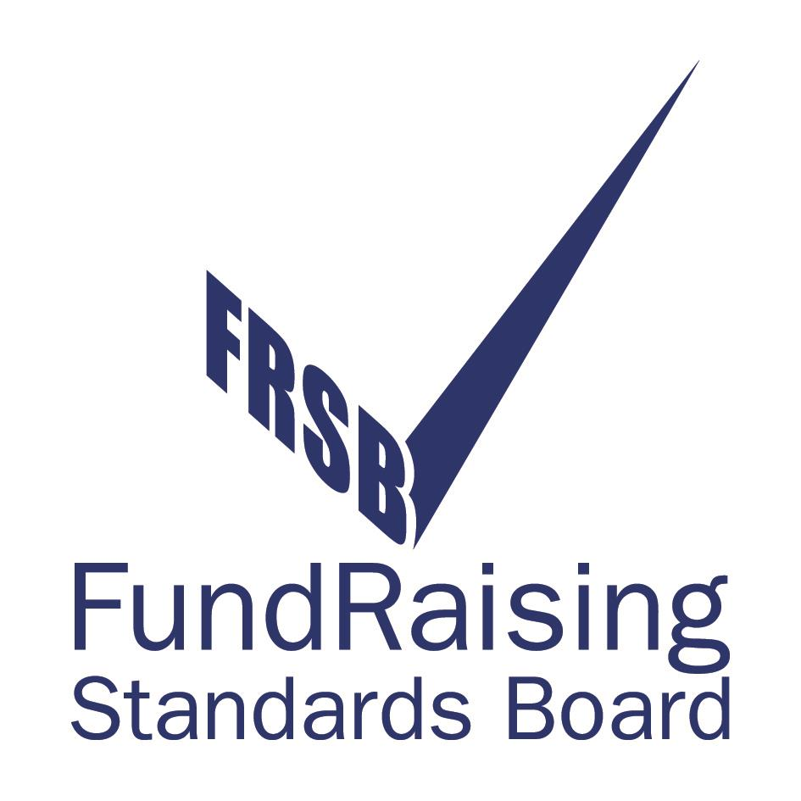


As per Hire Terms on Page 2 of St. Nicholas Centre Booking Form
As per Hire Terms on Page 2 of St. Nicholas Centre Booking Form and as displayed in room hired

