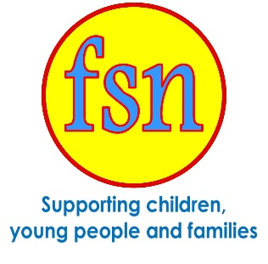

Volunteer Handbook

FSN volunteers, the helping hands that make a difference to people’s lives!

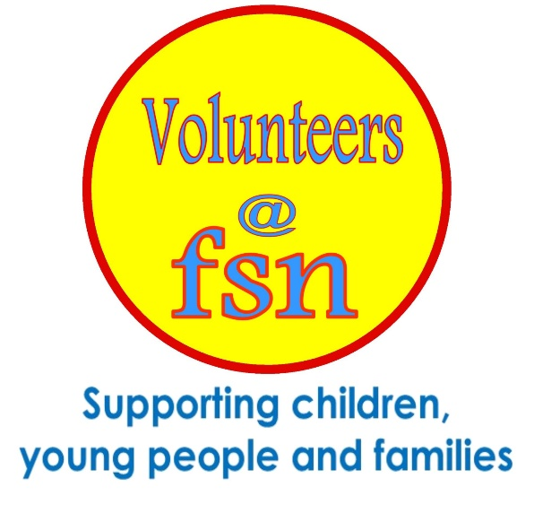

Updated June 2023

Contents

Welcome to FSN | Page 3
Volunteer opportunities – Early Years | Page 4
Volunteer opportunities – Children and Young People | Page 5
Volunteer opportunities – Supporting Adults | Page 6
Volunteer opportunities – Supporting Families | Page 7-8
Volunteer opportunities – Supporting running of the Centres | Page 9
What to expect – Recruitment process and induction | Page 10-11
Training and Support in daily role | Page 11-12
What you can expect and Volunteer Testimonials | Page 13
Policies and Procedures | Page 14-16
Volunteer provisions – expenses, concerns, references, Insurance | Page 17-18
Resting Volunteers | Page 18
Ending your volunteer role | Page 18
Line Managers details | Page 19

Welcome to FSN!

Our Mission:
FSN aims to provide effective and professional caring action without discrimination and favour for children and young people suffering the effects of poverty, disadvantage, neglect and abuse.

About Us
The charity was founded in 1939 and supports children, young people and families. Starting as children home’s then moving to extending into support through a range of projects. FSN have been based at the St Nicholas Centre in Central St Leonards since 1999. The charity has 3 nurseries and 2 Community Centres, as well as funded projects to support children, young people and adults with gaining new skills, mental health and bereavement support to progress and make positive changes to their lives.

Volunteers are a vital part of our organisation, supporting in a wide variety of roles. FSN is based in St Leonards on Sea, but support reaches out to Hastings, Rother, Eastbourne and Wealden.

Volunteering at FSN you can be part of a charity really making a difference to the lives of children, young people and families. Whether you are looking to gain more work experience and training or are looking for a role where you can feel valued and meet others, FSN has a selection of positions to choose from. You will be supported and have many opportunities to improve your skills and knowledge. Projects may change over time, but as an FSN Volunteer there will always be a range of activities where your skills and help will be appreciated.

FSN is proud to have achieved the Investing in Volunteers accreditation.
This quality standard is for organisations who show an expressed commitment to the involvement and recognition of the contribution our volunteers make. Investing in Volunteers aims to improve the quality of the volunteering experience for all volunteers, and demonstrates that we employ best practice in managing our volunteer experience.

Volunteering Opportunities at FSN

Supporting Early Years
Volunteers have opportunities to help with children’s play and learning, at mealtimes and with housekeeping.
Sessions run mornings or afternoons. You might want to volunteer once a week, or several sessions a week. This can be discussed with your line manager.

.
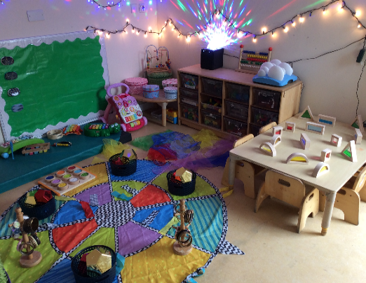

“I can see that my child has progressed in the time he has been there” Comment from Parent
Ofsted Report “Staff have warm, caring relationships with children. They are sensitive and responsive to their individual needs”
To learn more about early years at FSN please see our website
https://www.fsncharity.co.uk/nurseries
Theresa Gasson, the FSN Volunteer Coordinator can provide you with a copy of the current role description.
Please call 01424 377115 or email tgasson@fsncharity.co.uk

Supporting Children and Young People
FSN offer peer support groups where young people can share their feelings and experiences, using creative and therapeutic activities alongside group discussion. Children and young people have the opportunity to talk to others of their own age who may be going through similar experiences, and to gain support from each other.
The peer support groups are offered in the Hastings, Rother and Eastbourne areas and delivered by trained staff and volunteers. Sessions are delivered within schools as well as in our centres. Opportunities for volunteering include group session support, fundraising, events and administration.

Comment from parent:
"My child has been more confident with other people, goes to places on his own. He understands a lot more about feelings towards bereavement."
Comments from young people:
“Everyone was kind and never judged everyone.”
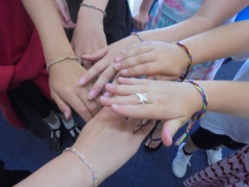
“I feel more open in front of other people now.”
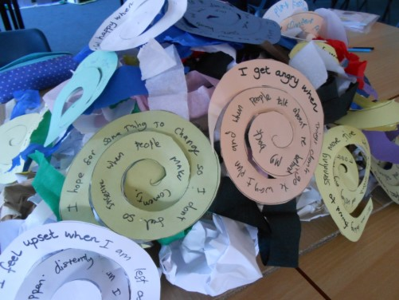
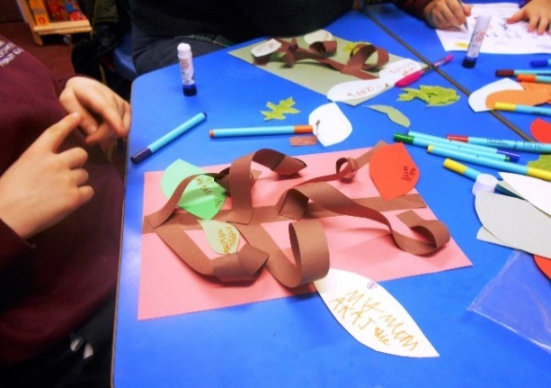

To find out more about bereavement and mental health support for children and young people at FSN, please see our website:
https://www.fsncharity.co.uk/projects/dragonflies-bereavement-project or
https://www.fsncharity.co.uk/projects/my-time
Theresa Gasson, the FSN Volunteer Coordinator can provide you with a copy of the current role description.
Please call 01424 377115 or email tgasson@fsncharity.co.uk

Supporting Adults

FSN offers courses, workshops and drops-ins for adults aged 18 plus to promote wellbeing, improve employability skills, healthier lifestyles and offer volunteering opportunities.
Volunteer roles include: tutor support, wellbeing group support, administration, food pantry support, running table sales, leading or supporting volunteer led activity groups and workshops (personal development, craft, IT etc.) and helping at events.
Activities run from the St Nicholas Centre, London Road, St Leonards and the Robsack Centre, Bodiam Drive, St Leonards.

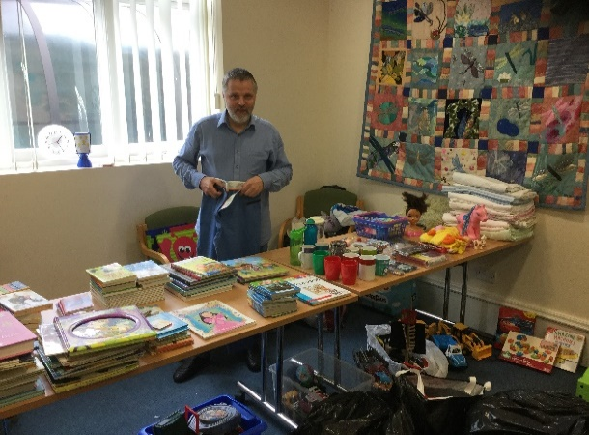
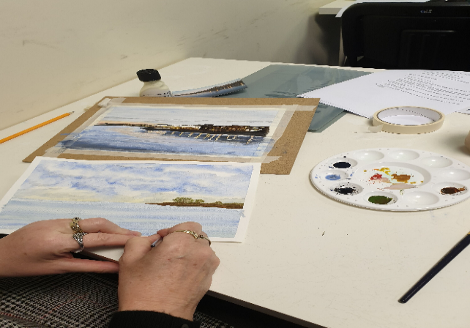

“Great being part of a team with a constructive view to education and fighting poverty!” Wellbeing Volunteer
“Volunteering at FSN has been a wonderfully rewarding experience. I feel my confidence has improved immensely, so much so I felt confident enough to run a volunteer led course.” Wellbeing Volunteer

To find out more about the adult support at FSN, please see our website:
https://www.fsncharity.co.uk/projects/health-and-wellbeing-communityhubs

Theresa Gasson, the FSN Volunteer Coordinator can provide you with a copy of the current role description.
Please call 01424 377115 or email tgasson@fsncharity.co.uk
Supporting Families

FSN offers workshops and training for families. Through the Family Learning workshops parents and children can enjoy developing the child’s communication skills together, having fun with arts, crafts and cookery.
Volunteer roles include: assisting families accessing groups and classroom assistant.
Workshops run from the St Nicholas Centre, London Road, St Leonards and the St Leonards Children’s Centre, Clyde Road, St Leonards.
To find out more about Family Learning courses at FSN, please see our website:
https://www.fsncharity.co.uk/training

Through the PACT project, parents can complete a fully funded accredited course to enable them to deliver Early Years drop in and play sessions in local Community Centres as a PACT Group Session Support Volunteer. Providing play and socialisation opportunities for families.
The PACT training is held weekly for 10 weeks at the St Nicholas Centre, London Road, St Leonards.
To find out more about PACT courses at FSN, please see our website:
https://www.fsncharity.co.uk/projects/pactparentandchildrentogether

The Hub Project is for families who are living in:
- temporary
- insecure (e.g. who have received an eviction notice)
- inappropriate accommodation (e.g. overcrowded properties or properties in a state of disrepair)
The Hub offers a space to get support, talk through issues, enjoy games and activities and meet other families.
Where additional help or advice is required the Hub staff will assist with finding the appropriate organisation for support.
Open to families in Hastings, St Leonards on-Sea, Rother and Eastbourne.
The Hub aims to:
- Reduce feelings of anxiety
- Improve wellbeing
- Reduce isolation
- Build resilience
- Reduce the stigma associated with being without a home.
Volunteers have opportunities to help with The Hub sessions, interacting directly with the families to facilitate activities and enjoy working with the rest of The Hub team.
To find out more about The Hub Project at FSN, please see our website:
https://www.fsncharity.co.uk/projects/the-hub

Theresa Gasson, the FSN Volunteer Coordinator can provide you with a copy of the current role description.
Please call 01424 377115 or email tgasson@fsncharity.co.uk

Supporting the running of the Centres

FSN manages two centres, The St Nicholas Centre and The Robsack Centre. Volunteer opportunities at these centres include: reception, groundworks, gardening, setting up rooms, centre maintenance, administration, fundraising, pantry and café support.
The centres are in the middle of busy communities and offer activities for the whole family, room hire to external organisations as well as being the base for our projects.

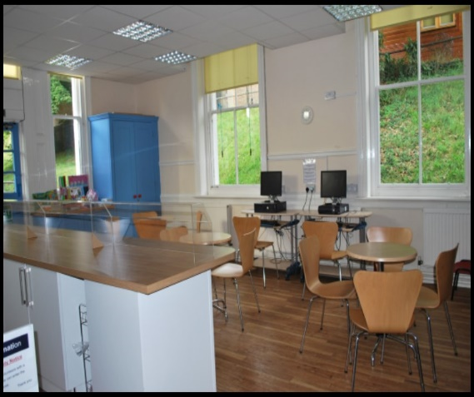
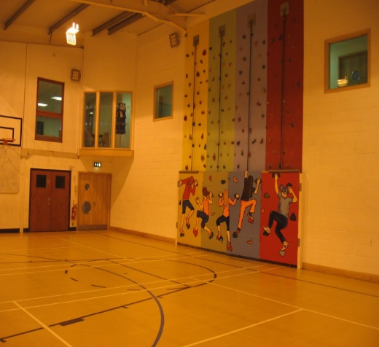

To find out more about our centres, please see our website:
https://www.fsncharity.co.uk/about-us/our-facilities
Theresa Gasson, the FSN Volunteer Coordinator can provide you with a copy of the current role description.
Please call 01424 377115 or email tgasson@fsncharity.co.uk

Volunteering: What you can expect from FSN
Volunteer Coordinator
FSN has a volunteer coordinator, Theresa Gasson who will help and support you throughout your time at FSN. She will guide you with your initial enquiries, host your volunteer interview and induction, and route your application to become a volunteer at FSN. When volunteering at one of our centres, Theresa will continue to meet to support you and keep you up to date with any volunteer news, events and meetings.

Recruitment Process
If you are interested in becoming a volunteer at FSN, you can look at our website for more information on the projects and services www.fsncharity.co.uk or alternatively you can call Theresa Gasson on 01424 377115, or email tgasson@fsncharity.co.uk to get more information about our volunteering opportunities to help you make your choice. Projects recruiting for volunteers will be advertised on our website and also on our Facebook pages. Role descriptions are in place for all projects, to give an overview of your role. Once you have completed your application form (help is available to do this) and know where you would like to start your volunteering journey, a visit can be arranged to the project you are interested in, where you will have an opportunity to have an informal interview with Theresa to learn more about your chosen opportunity.

Disclosure & Barring Service (DBS)

FSN works with vulnerable children and families and all staff and volunteers are police checked. You will be asked to fill in a DBS Form and to bring in documents to confirm your identity. The Volunteer Coordinator will support you with this and once the check is verified and approved, and we have received two satisfactory references you will be able to start volunteering.
Due to the vulnerability of FSN service users, we cannot offer volunteering opportunities if you have convictions relating to children or violence. Those with other convictions within the past 10 years will require some further review, but may not stop your opportunity to volunteer. All information regarding convictions are treated in a confidential manner and will only be disclosed to those responsible for decision making and managing the individual (if relevant).

Induction

The Volunteer Coordinator will take you through a process called ‘Induction’ which will explain FSN’s background, your role, health and safety requirements, share FSN policies and show you around the building. They will also introduce you to your Project Line Manager, colleagues and the people you will be supporting. It will be an opportunity for you to discuss any worries or concerns and learn more about your role.

Training and Support

Support in daily role and supervisions
The Project Line Manager will support you (or allocate someone) who will help you with your day to day tasks, show you where things are kept and explain the routines of the role and any safety considerations.
Your Volunteer Coordinator and Line Manager will organise a time to meet with you on a regular basis known as ‘supervision’. This will take place every term (around 3 times a year). You will be able to discuss any ideas or problems you may have. If you are asked to complete tasks that are beyond your skill set or outside of your volunteer role this can also be discussed so that further training, mentoring or development can be planned. This should help open two-way communication and make your volunteering an enjoyable experience.

Attendance

FSN relies on the help of all its volunteers and attendance is important. Please advise the Volunteer Coordinator or Line Manager if you are going to be absent from your volunteering role. In the event of sickness or other emergencies, please telephone the Volunteer Coordinator or your Line Manager giving as much notice as possible so that alternative arrangements can be made. Please give as much notice as possible for any other planned absences such as holidays or rest periods (See page 17).

Training Requirements
During your Induction, you will be required to complete safeguarding training and be offered opportunities that will further support you in your role e.g. food hygiene, first aid, IT skills and personal development skills.

If you are actively volunteering, you will be offered opportunities from time to time to improve your confidence and skills, or to give feedback on any training you have received.

“I started to volunteer with FSN in the Health and Wellbeing Hub. I then started a level 3 course at FSN through another of their projects. The course started me on this new path and changed my life.”
FSN Volunteer
“I have been at FSN since 2010. Volunteering has changed my life. It is not only the staff who are always there to help you when you are at your lowest and feel down, but it’s also a place where you can come and meet people.
Volunteering for FSN has changed my life!”
FSN Volunteer

Monthly Newsletters

FSN send all staff and volunteers an electronic monthly newsletter to keep you updated on what is happening at FSN.

What you can expect from us What we expect from you
- To perform tasks and undertake training in line with your role
- To commit to FSNs values and treat volunteers, staff and service users with respect
- To follow the organisations policies and procedures with regards to volunteering
- To communicate any challenges to your line manager
- To respect confidentiality, but also to ensure any safeguarding concerns are reported
- To represent the organisation in a professional way at all times
- To practice good time keeping; if you unable to volunteer for a session or are unwell please notify your line manager in good time to allow cover to be arranged

- To be respected, valued and appreciated
- To be inducted into your role and have an understanding of what is expected of you
- To be supported to have an understanding of our policies and procedures
- To be offered training we feel might benefit you in your role
- To keep you safe whilst volunteering
- To have your views heard: we will send out annual surveys to have feedback from you, as well as including your views as part of supervision
- To provide a reference for your time at FSN if you have volunteered for over 6 months. (see page 16)
- To have your out of pocket expenses reimbursed
- To have any concerns dealt with promptly

Volunteer Testimonials

"I volunteer to give something back for the many blessings I have in my life, but actually, the young people give me so much more than I could ever hope to give them!" My Time Volunteer

“My first interaction with FSN was when I attended a course, which had a very positive influence on me. I was so impressed by the positive effect FSN had on me that I now volunteer. I am encouraged to be involved and have a sense of purpose. This has definitely improved my mental health and sense of wellbeing. As soon as I go through the doors of FSN the accepting and welcoming environment is an inspiration. Wellbeing Hub Volunteer

Policies and Procedures

Our projects aim to support people in our communities, which includes our own staff and volunteers. Our range of policies create safe working practices to protect service users, volunteers and staff.
During your Induction the Volunteer Coordinator will take you through our policies and procedures and give you time to read them. They will always be on hand to help you understand them and answer any questions.
There are a number of policies that may impact your role, please be aware that you can also talk to your Line Manager/Leader who is trained to support you and ensure your safety.
FSN has an independent Board of Trustees that monitors and supports our work; they are also volunteers.

Safeguarding

Because we are a charity working with children, young people and families, it is important that you know about our Safeguarding Policy. You will receive training on this but if at any time you are worried about a child, young person or vulnerable adult, you should speak to your Manager immediately so that the right action can be taken. If you cannot get hold of your Line Manager, then you should speak to the Volunteer Coordinator or the Safeguarding Leads. You will be introduced to them during your induction.

Confidentiality
You may have access to information about the organisation and the people we work with. Our Confidentiality Policy means that you will agree not to discuss any of this information with any other person unless you have a concern and you feel that a staff member needs to know to ensure the health and safety of the people you are involved with (see our Safeguarding Policy). Please report any concern to your Line Manager and if they are unavailable you can talk to the Volunteer Coordinator or one of the safeguarding leads.

Data Protection and GDPR
FSN is committed to protecting the rights and freedoms of data subjects and safely and securely processing their data in accordance with legal obligations to General Data Protection Regulations.

FSN holds personal data about our employees, service users, volunteers, suppliers, donors and other individuals for a variety of business purposes.
The data FSN holds must be kept safe and secure. For written documentation, this means it is stored in a locked filing cabinet at all times. Computers holding personal data will be logged off or closed down when the authorised user leaves the workstation. Access to systems is controlled by secure passwords. Users must never document or divulge their password to another person. The Volunteer Privacy notice policy outlines the kinds of data held and its purpose, as well as your rights to view this information.

Equal Opportunities and Diversity
FSN values all its services users, staff and volunteers. To ensure that people are given appropriate respect and an opportunity to access our services without discrimination or favour, FSN has an Equal Opportunities & Diversity Policy. We ask that all volunteers abide by this policy so that everyone regardless of race, gender, marriage and civil partnership, gender reassignment, disability, sexual orientation, age, religion, will always feel welcome and valued when they are with us. FSN regards discrimination, harassment, bullying or victimisation as serious misconduct. All complaints will be taken seriously and appropriate measures including disciplinary action may be brought against anyone who unlawfully discriminates against, harasses, bullies or victimises any other person.

Volunteer Policy
Volunteers are a valuable part of our organisation. They complement and support our existing staff base bringing with them a wide range of individual skills. FSN aims to nurture volunteer’s development, offering opportunities through a range of experience and training provision. FSN listens, values and responds to volunteers’ suggestions and recognises that successful volunteer involvement requires an open two-way communication leading to mutual understanding and a good relationship between the organisation and volunteer.

The volunteer policy contains recruitment, training and information on areas such as claiming your expenses, raising any concerns and other relevant information. The volunteer policy should be included within your induction pack.

Code of Conduct
FSN aims to provide welcoming, safe and positive experiences for all children, young people and families and a supportive working environment for staff and volunteers. FSN expect standards of behaviour that ensure that everyone is treated with courtesy and respect and that no safety guidelines are infringed. The Code of Conduct applies to everyone - staff, volunteers, parents and carers, young people and children. It means avoiding behaviour that can be offensive or unsafe, for example - offensive language, no smoking (including e-cigarettes) in projects or in the immediate environment, no physical or verbal intimidation of anyone using the facilities.

Health and Safety
FSN seeks to provide a safe working environment and undertakes to conduct its operations in such a way as to ensure the health and safety of its employees, board members, volunteers, service users and all who visit its premises.
FSN has a duty of care to you to ensure your health and safety. You also have a duty of care to yourself which means you must always talk through any task that you wish to do with your Manager. There may be a legal health and safety requirement around the task you have in mind and there may be times when you are not able to do something until we have carried out a risk assessment.

Expenses
FSN volunteers are entitled to claim expenses. These include:
- Travel to and from the place of volunteering
- Travel undertaken in the course of volunteering
- Light meal taken during the period of volunteering (if over 4 hours)
- Postage and telephone costs if required for the volunteering activity
There is a short form to be filled in to claim expense which will need to be approved by your Volunteer Coordinator or Line Manager.

Problem Solving

FSN will endeavour to address any issues and to seek to find ways of meeting
volunteers’ needs as well as those of the organisation, staff and service
users.

If a volunteer has a problem or a concern, they should talk to their Line Manager first. He/she will best understand the way the project service is delivered and the people within it.

If this is uncomfortable for any reason, speak to the Volunteer Coordinator or HR based at St. Nicholas Centre, London Road. You will be listened to in the strictest confidence and efforts will be made to resolve any problems. FSN will then follow the procedure as set out in the Volunteers problem solving policy.

References

FSN are happy to complete references for volunteers who have been actively helping for more than 6 months. References can only be offered within three years of leaving the organisation. You should obtain permission from your Line Manager to give their name and the address at FSN as a referee. HR and your Manager will then complete the reference.

Insurance

Volunteers helping in the projects are fully covered by FSN’s Employer’s Liability Insurance. To ensure that the insurance is valid:
- Certain tasks within your role may need to be risk assessed
- A proper qualification may be required
- A current DBS must be held by HR
- Regular supervision reviews of your role must take place.
These measures will ensure that you are protected at all times.

Resting Volunteers

If a volunteer needs to take time out for health or personal reasons this is known as ‘Resting’. FSN aims to maintain a flexible and sensitive approach to supporting our volunteers and has a policy which sets out the limit and procedures for any rest period. A record of the resting period will be kept on file and the volunteer coordinator will keep in touch as appropriate to individual circumstances. Depending on the length of the rest period, a returning volunteer may be required to refresh both their DBS and safeguarding training before resuming their role. Volunteers returning after an extended absence will be invited to sign up as a new volunteer and follow the induction process.

Ending your Role

We are delighted to have you as a Volunteer but understand that you may need or want to move on. You can opt to be put on the “resting” volunteer list if you decide to have a period of time off. A volunteer who is “resting” for more than three months will need to renew their DBS before commencing volunteering with us again. If you are leaving on a permanent basis you will be asked to complete and exit questionnaire with the Volunteer Coordinator so that we can evaluate your experience and thank you for your time. If you have not volunteered for six months (without a discussion with the Volunteer Co-ordinator) you will be asked to complete an exit questionnaire.

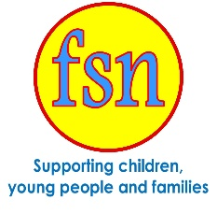
For Your Records
Start Date: Project Supporting: | Line Manager: Job Title
Contact Number Email Address | Address where based

Theresa Gasson Volunteer Coordinator
01424 377115 tgasson@fsncharity.co.uk
Jackie Earl HR Department
01424 377103 jearl@fsncharity.co.uk
Space for notes

