**What we offer**

* **Youth led activities including sports, drama, dance, singing, art, games**
* **AQA Awards**
* **CV writing, motivational skills, mentoring and support**
* **Youtube content creation**
* **DJ skills**
* **Eco skills**

**and more!**

**A free youth group supporting the emotional wellbeing of young people aged 11 – 18**

**fsncharity.co.uk**

**What is the youth project?**

BYP is a fully funded youth club for young people in the local community. The project runs Mondays and Wednesdays 5 – 7pm

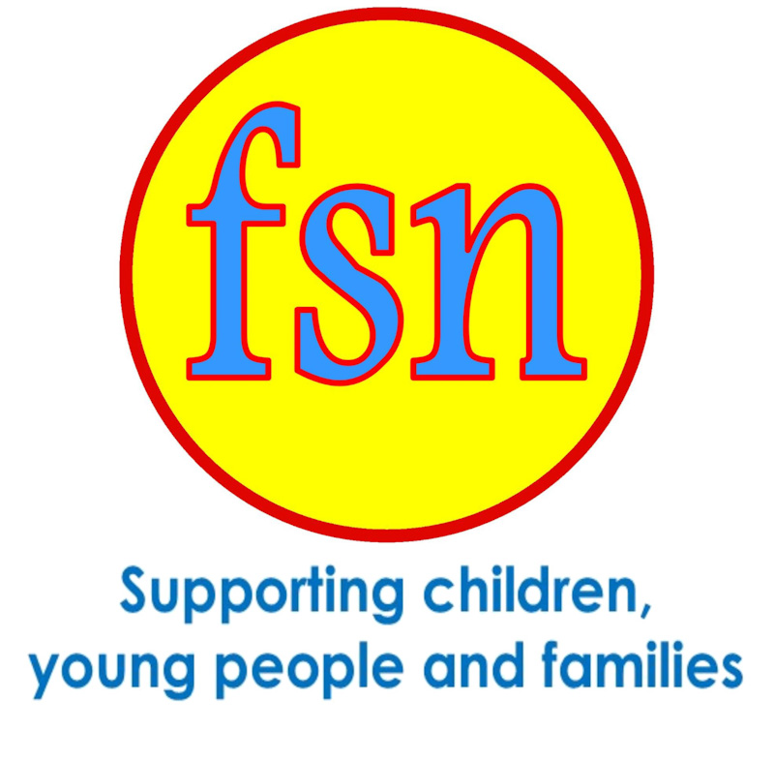

**Bexhill Youth Project**

Type: [mdavey@fsncharity.co.uk](mailto:mdavey@fsncharity.co.uk)

Talk: 0784 230 6748

Visit: FSN St Nicholas Centre, 66 London Road, St Leonards on sea, East Sussex TN37 6AS

Registered Charity No. 208446

**What is it for?**

A place for young people to use their own experiences to help other young people. We provide a space for young people to support each other where they feel accepted and understood.



